# Introduction

## Functional features

Hexagonal-annular braiding is the current advanced 3D braiding technology, which provides a variety of complex and novel structures for composite preforms. Based on this, the 3D hexagonal-annular braiding technique and the modelling method to predict its fabric structure are proposed. A novel algorithm for controlling the trajectory of the yarn carrier using a computational matrix is proposed, in which the horn gear, the yarn carrier, and the parameters of the braiding process are represented by mathematical matrices. Their relationship with the fabric structure is established by computer-aided matrix operations, and the effect of different 3D hexagonal-annular braiding process parameters on the fabric structure is investigated. The parameters are modified according to the desired braiding process so as to simulate and predict the braided structure.

# Operation process

Open the installation file *BSSAappV01*，followed by determining whether the Matlab runtime environment is installed on the user's computer, if it is installed, select the program in the *for_redistribution_files_only* folder to install; if the Matlab environment is not installed, select the program in the *for_redistribution* folder to install. program in the *for_redistribution* folder. Take the example of not installing the Matlab environment for illustration.

## Software installation

Double-click on the *BSSAappV01.exe* installer

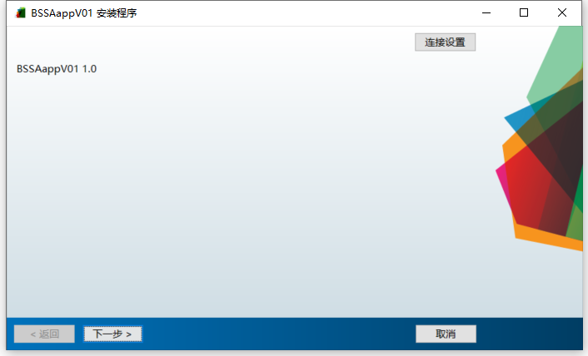

Click next and select the installation folder

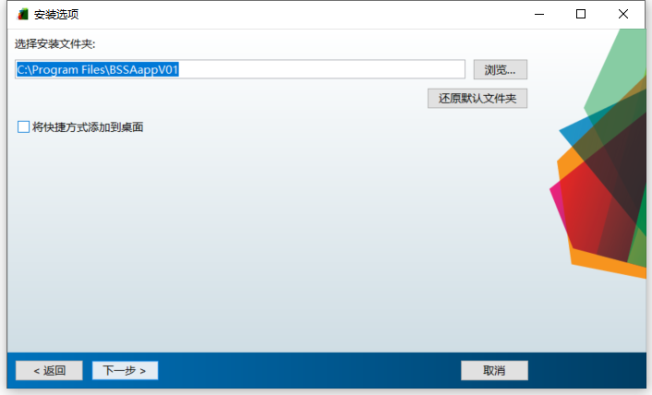

Select the Matlab environment Matlab Rumtime installation folder

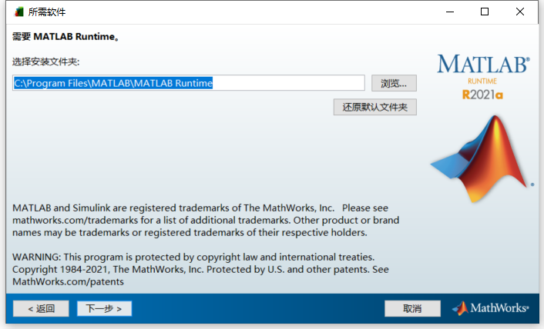

Receive permission and click Next

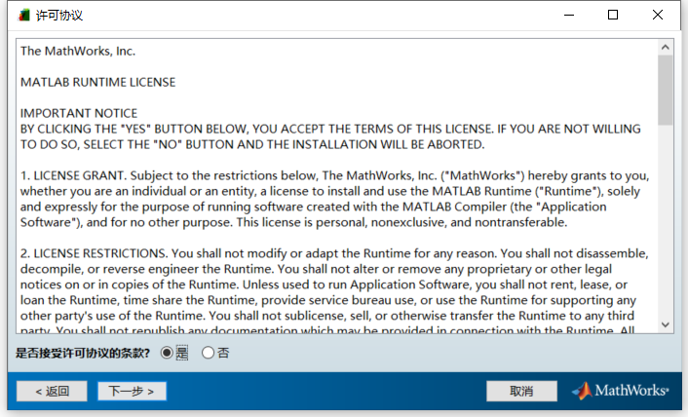

Click to install

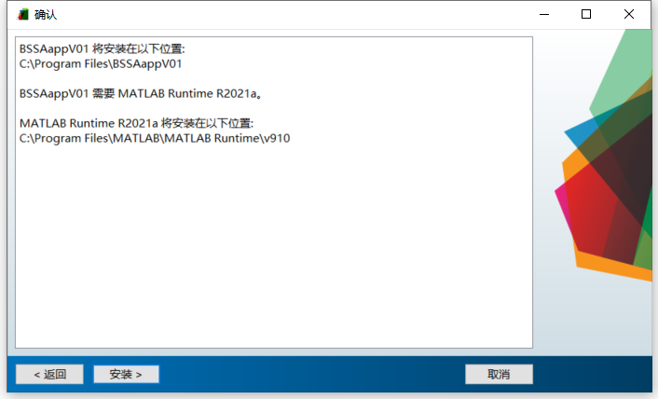

Wait for installation to complete

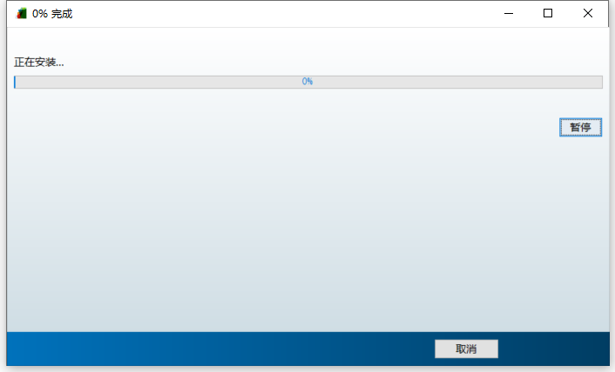

Installation completed

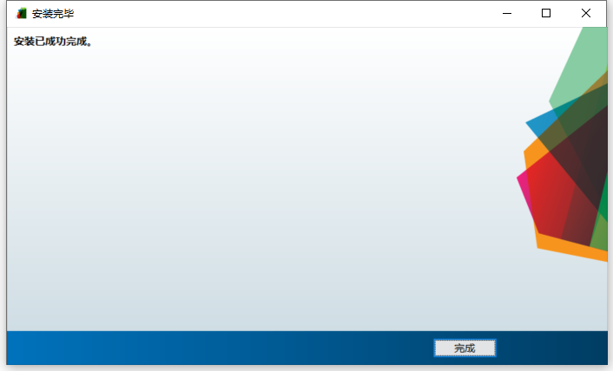

## Software operating instructions

Click the icon of **BSSAappV01** on the desktop, double-click it and open the software. The following figure shows:

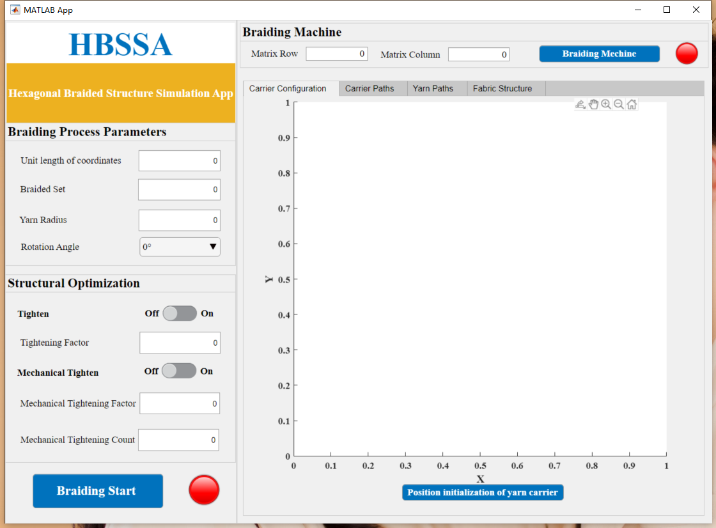

In this interface, the operator can view information about the weaving data, such as **Unit length of coordinates**, **Braided Set**, **Yarn Radius**, **Rotation Angle**, **Tightening Factor**, Mechanical Tighten, **Mechanical Tightening Factor** and **Mechanical Tightening Count**.

## Digital braiding machine

After the operator has successfully logged into the system, first establish the braided machine matrix, enter the matrix rows and columns, click **Braiding Machine** after input, the red light becomes green, if there is a 0, the red light remains unchanged for the green light, generally set the matrix row 30 columns 60, set to be greater than these two parameters:

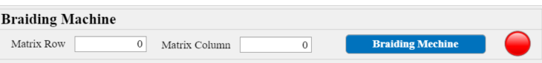

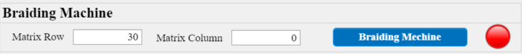

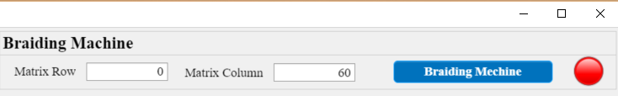

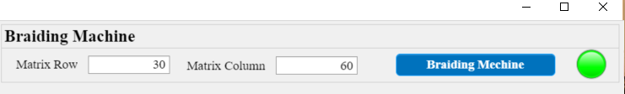

Click on the **Position initialization of yarn carrier** in the **Carrier Configuration** in the simulation drawing box to generate the yarn carrier distribution:

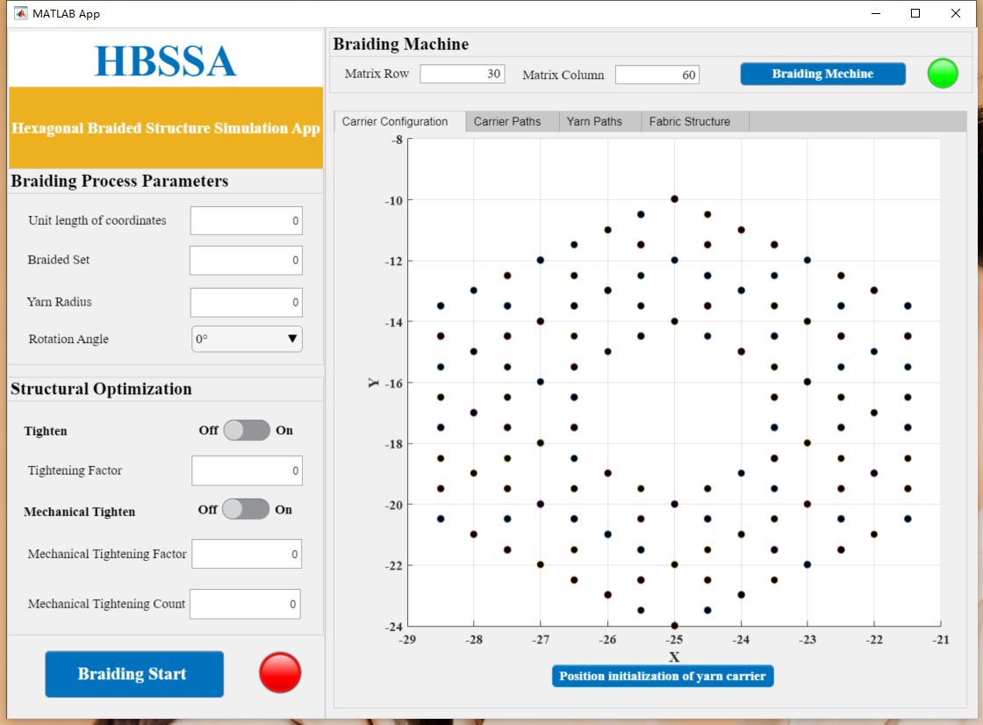

At the parameter definition, the main parameters are defined according to the braiding process parameters. For example, a braided yarn with a coordinate width of 1, a braiding step of 20 and a radius of 0.3 is selected with a rotation angle of 60°, a tightening switch on, a tightening factor of 1, a mechanical tightening switch on, a mechanical tightening factor of 0.4 and an iteration factor of 3. The parameters are defined at：

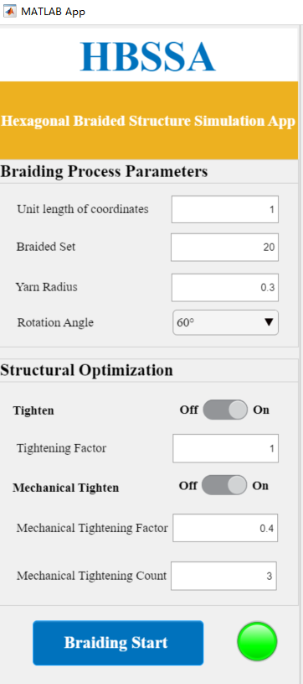 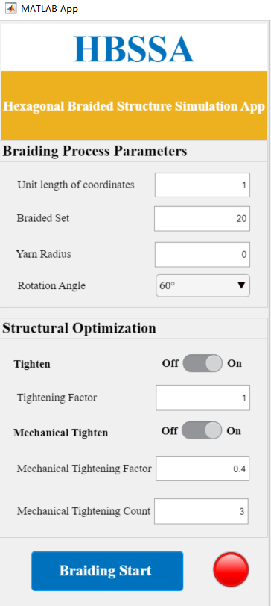

Note: If an error occurs when one of the parameters shown in the figure is 0, the red light does not turn green at this time.

## Fabric structure simulation

### Yarn carrier trajectory simulation

Click on **Carrier Paths** in the simulation drawing interface to simulate the carrier paths. Fill in the drawing view and Z-axis height as needed, then click on **Carrier Paths Calculation** to generate the carrier paths. Select the number of yarns according to your needs. By changing the number of fibers, you can get the braiding orientation of each fiber, with the maximum number of fibers being 120.

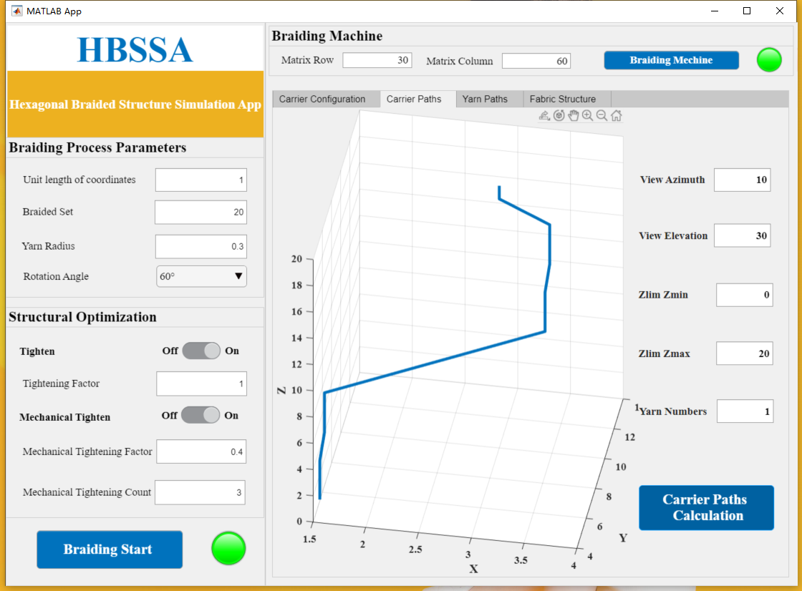

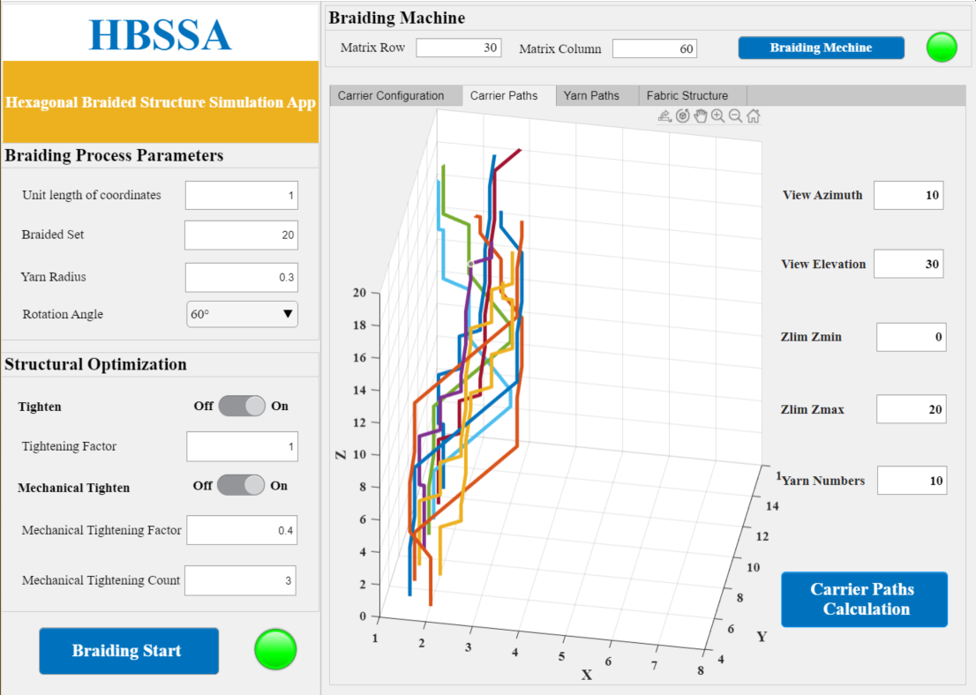 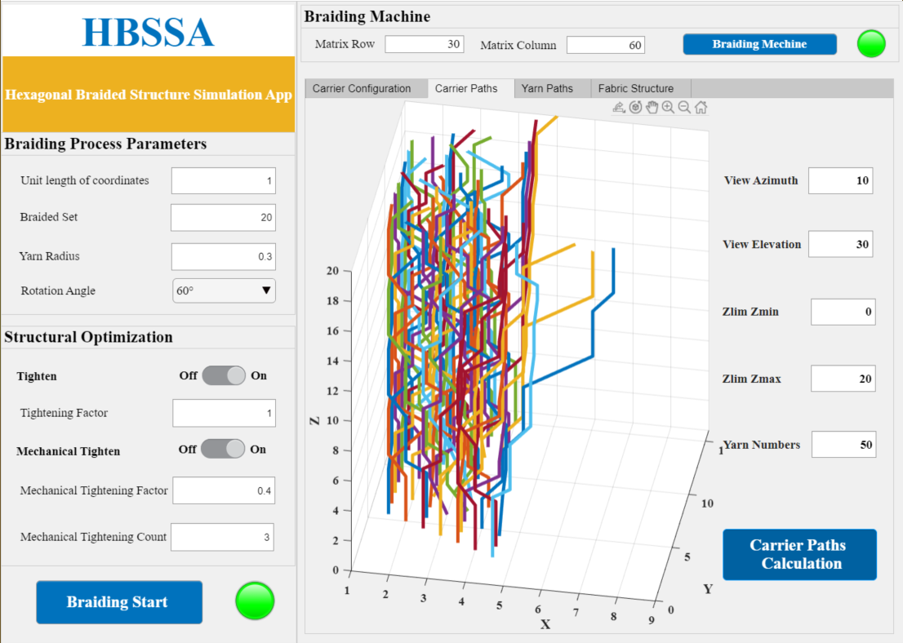 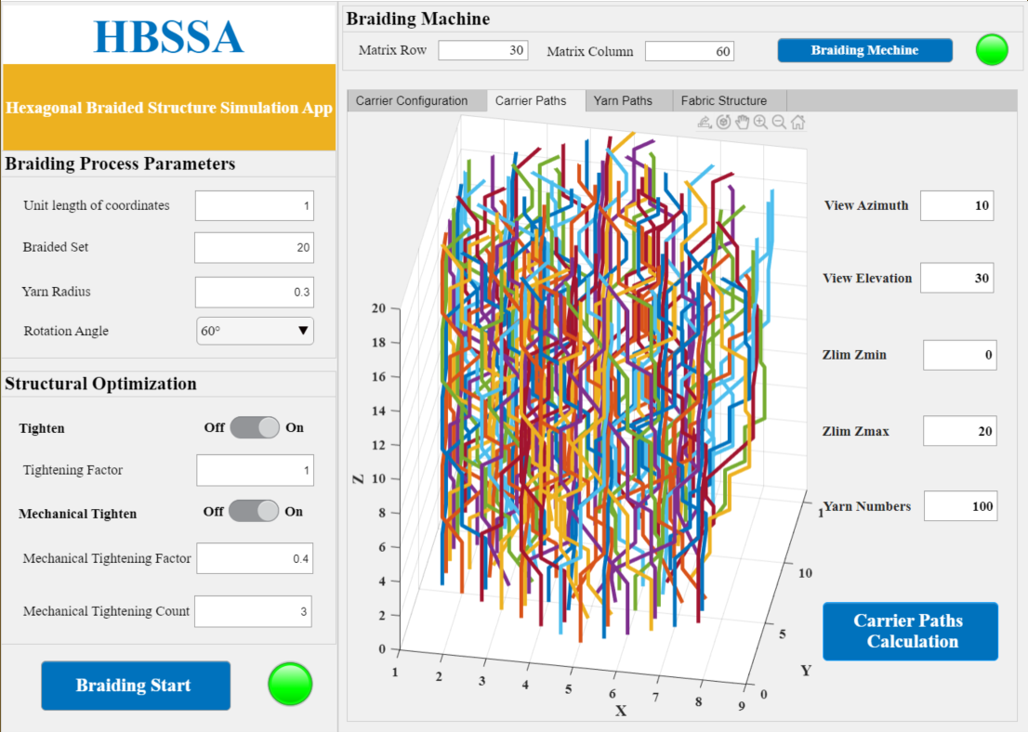 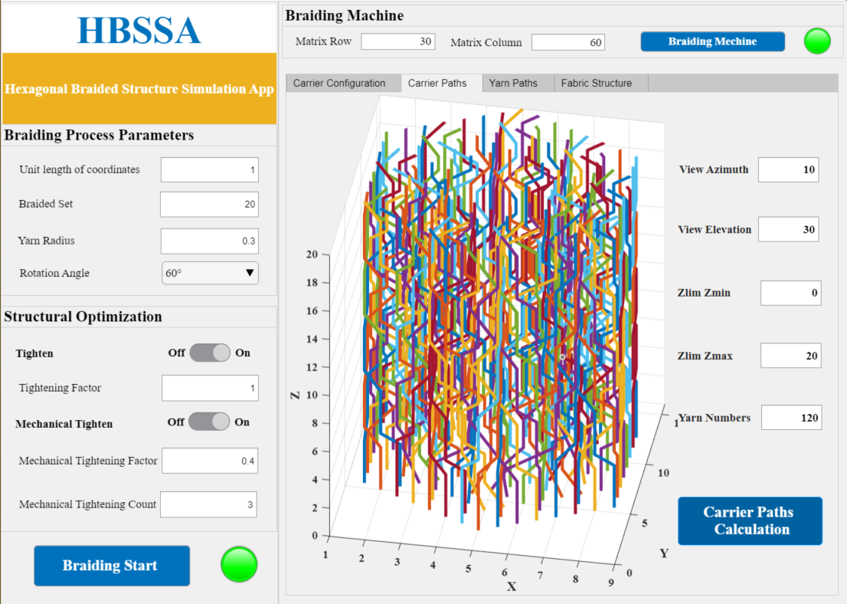

### Yarn trajectory simulation

The simulation of yarn paths is done by clicking **Yarn Paths** in the simulation drawing box, filling in the drawing perspective and Z-axis height as needed, and then clicking **Yarn Paths Calculation** to generate yarn paths.

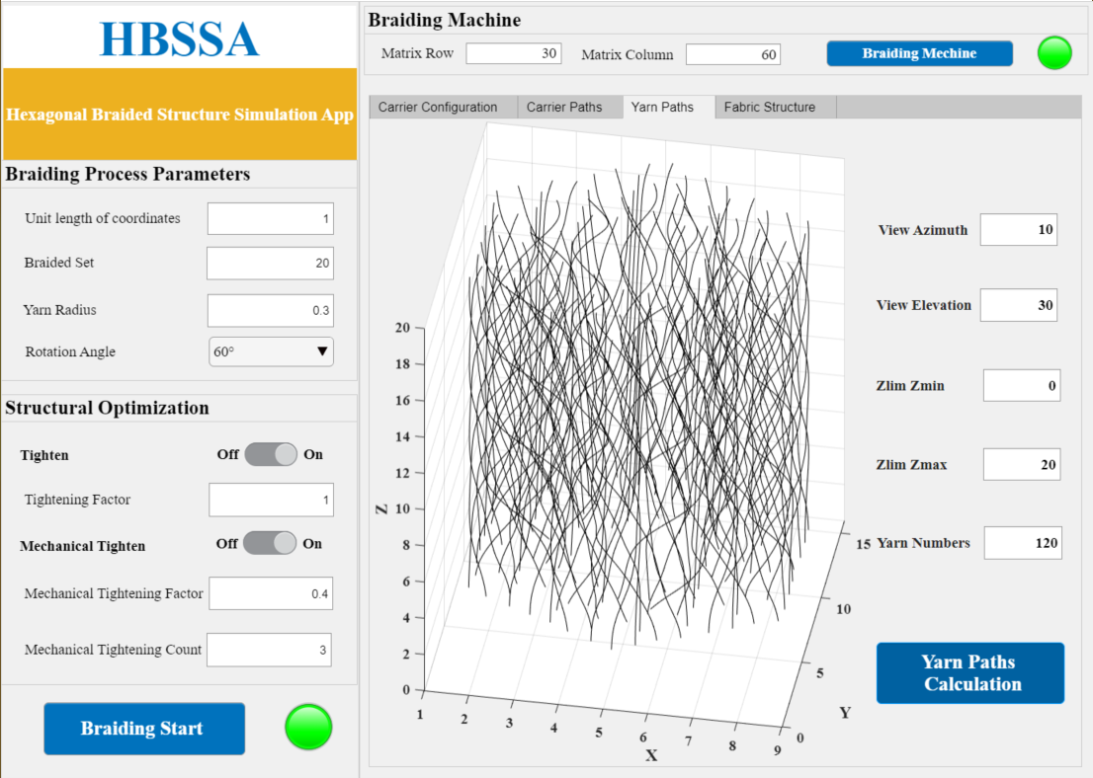

Similarly, different fiber braiding orientations can be obtained by changing the number of fibers up to 120.

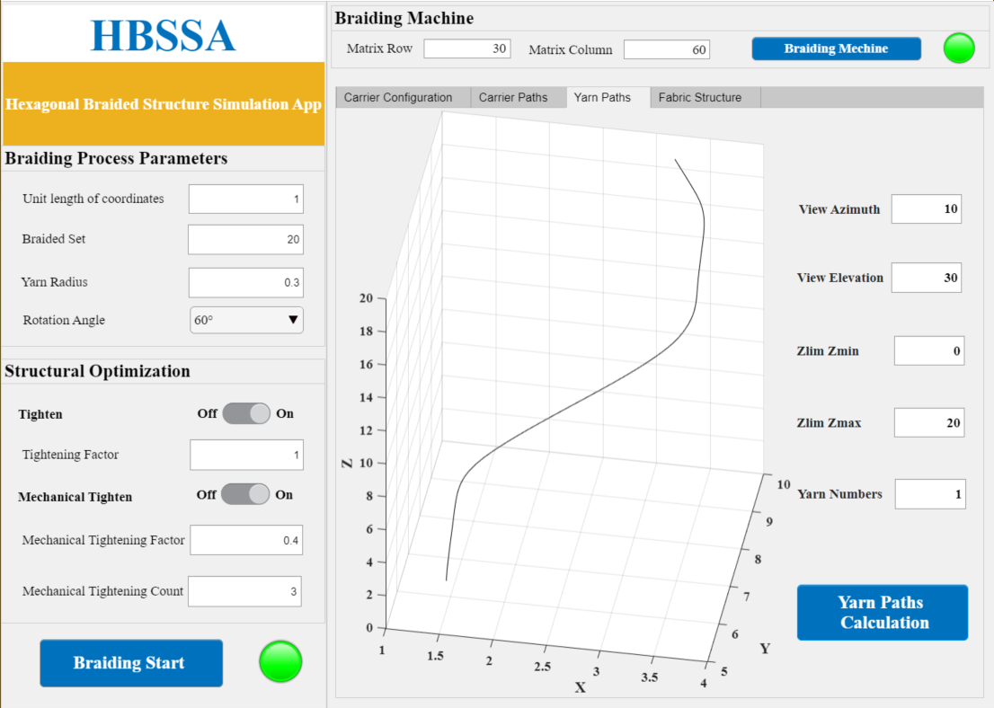

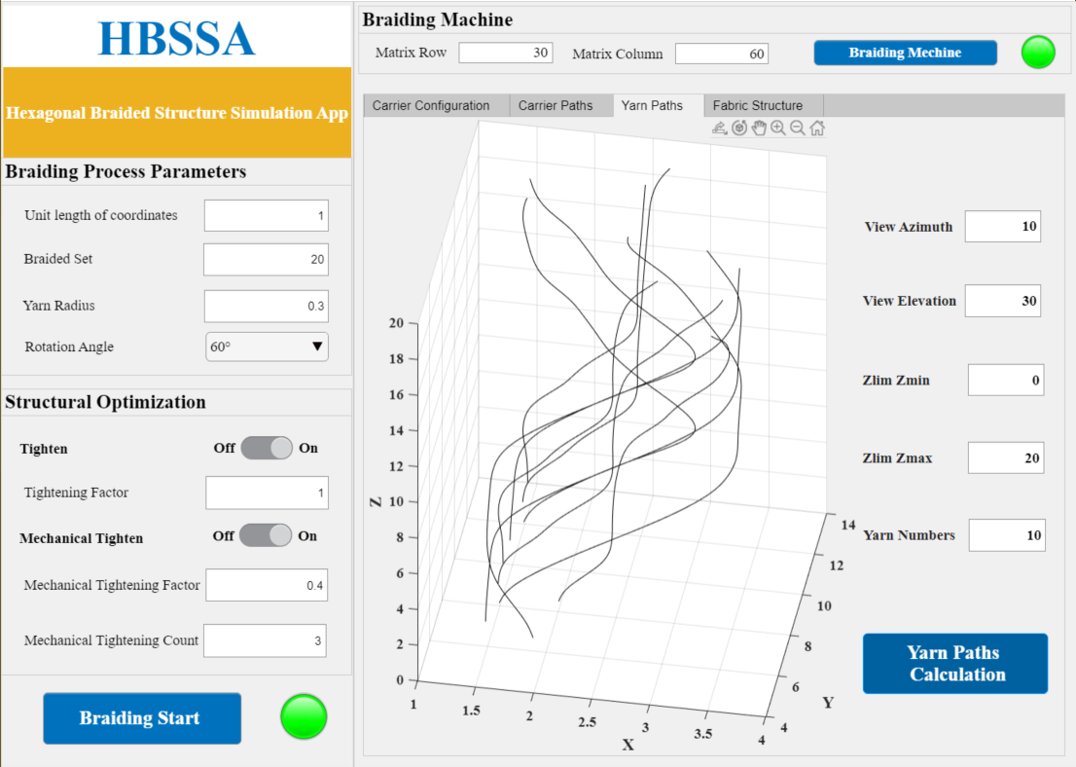

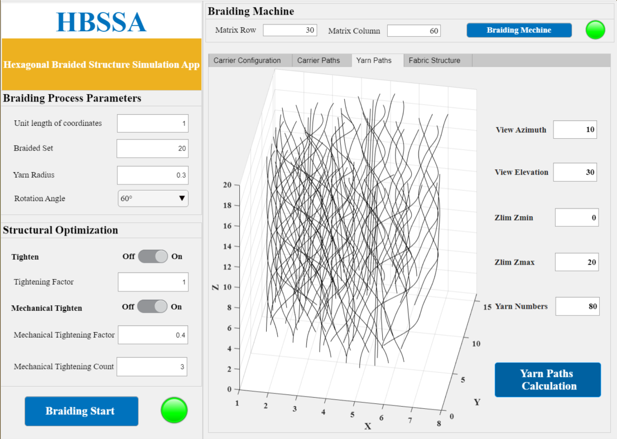

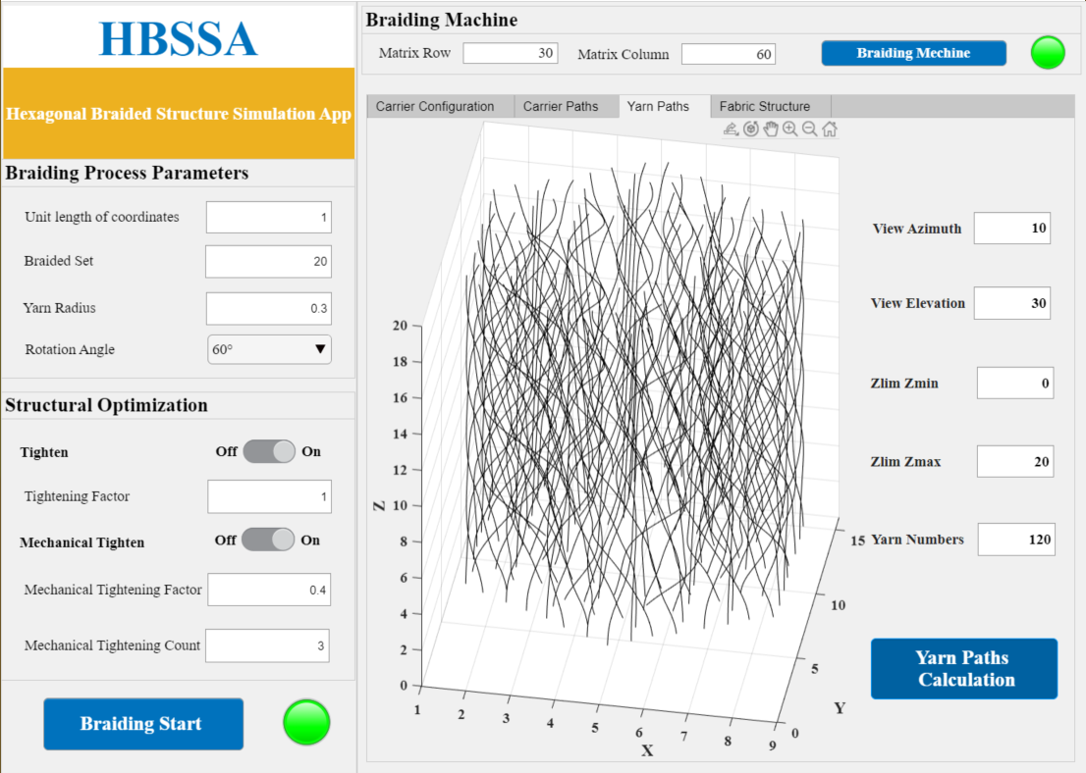

### Simulation of solid braid structure

Click **Fabric Structure** in the simulation drawing box, fill in the drawing perspective and Z-axis height as needed, and click **Fabric Structure Calculation** to generate the yarn-carrying path.

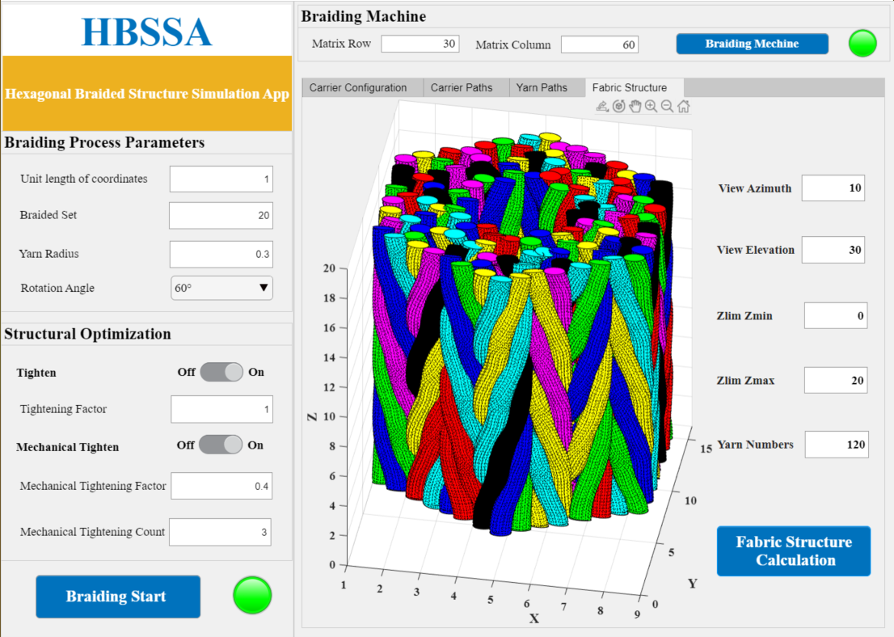

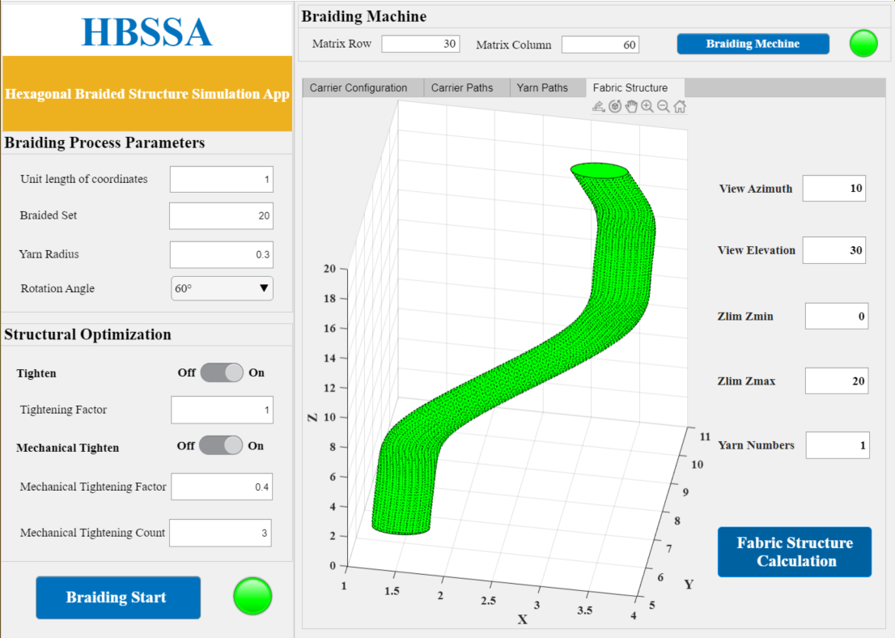

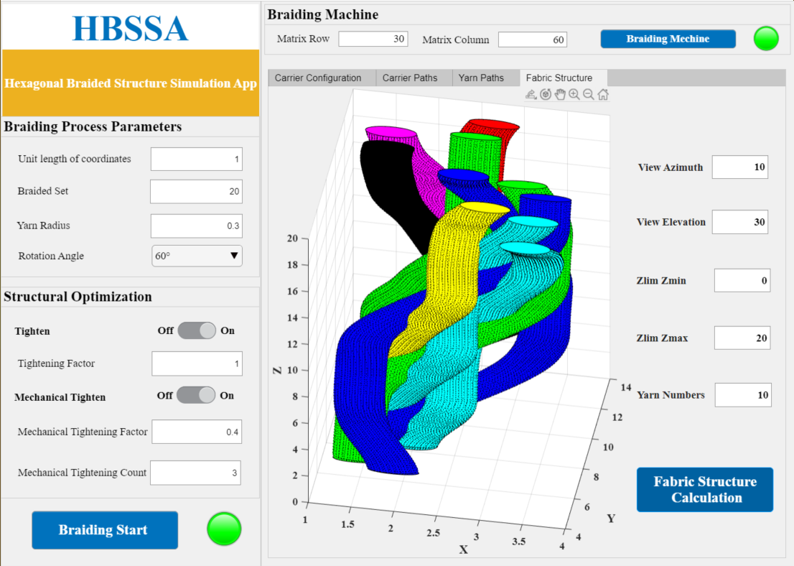

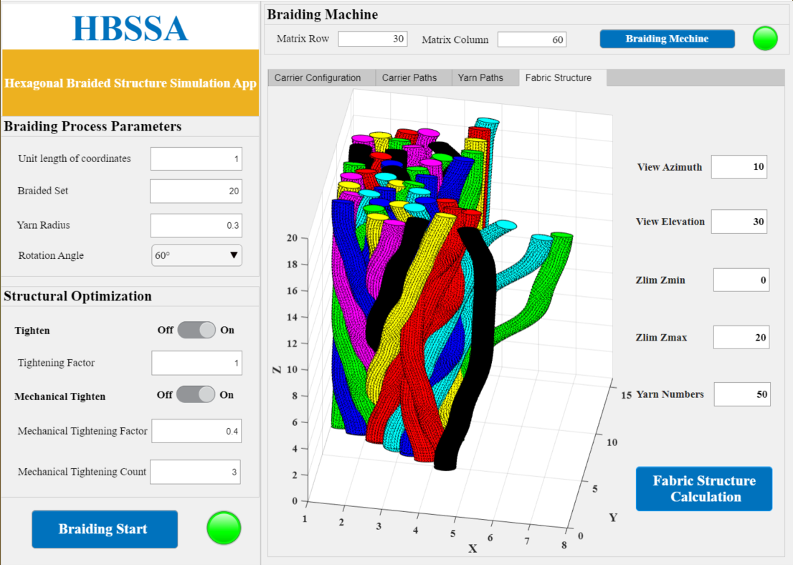

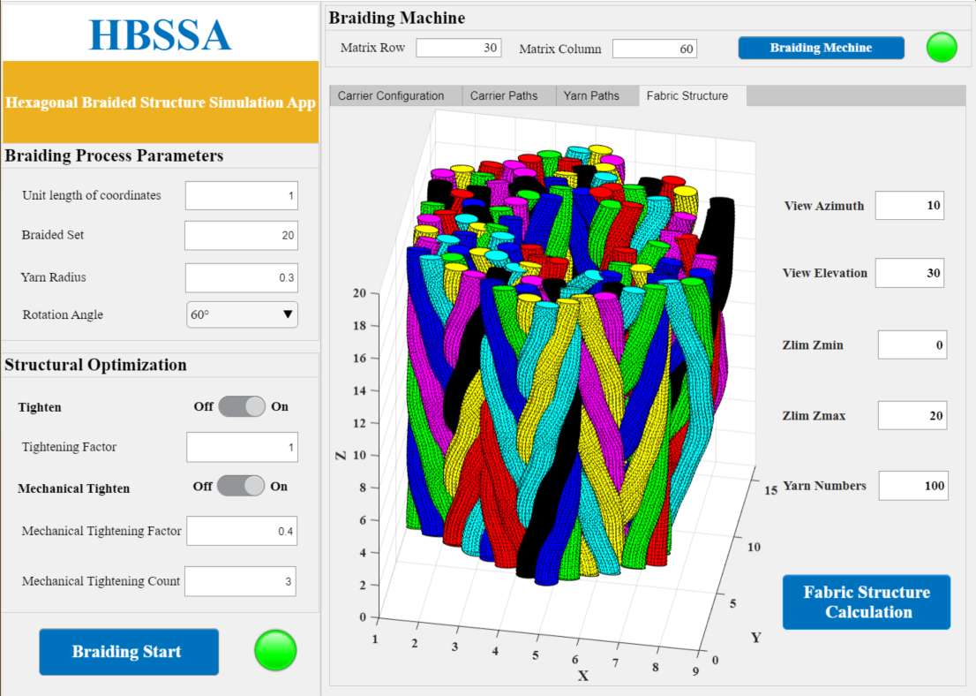

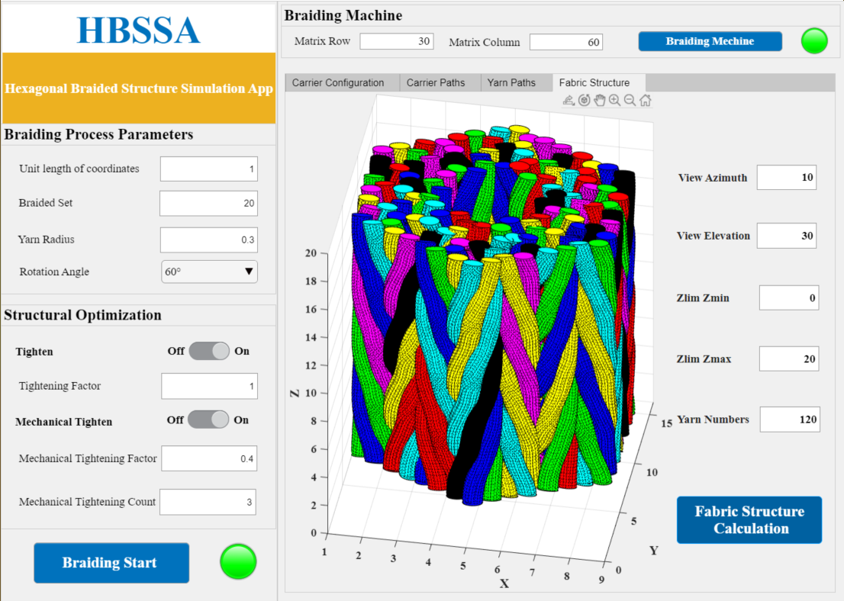

## Optimization of computer simulation trajectories

The optimized simulation trajectory is close to the real braid structure and yarn path, and the real trajectory of the fibers can be observed with the tightening factor turned on. After turning off the tightening factor, all coefficient values are changed to 0.

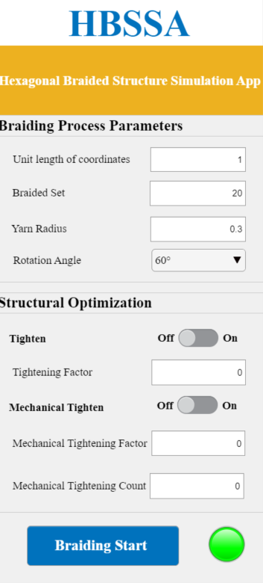

The state of the fiber is observed when it is not mechanically tightened.

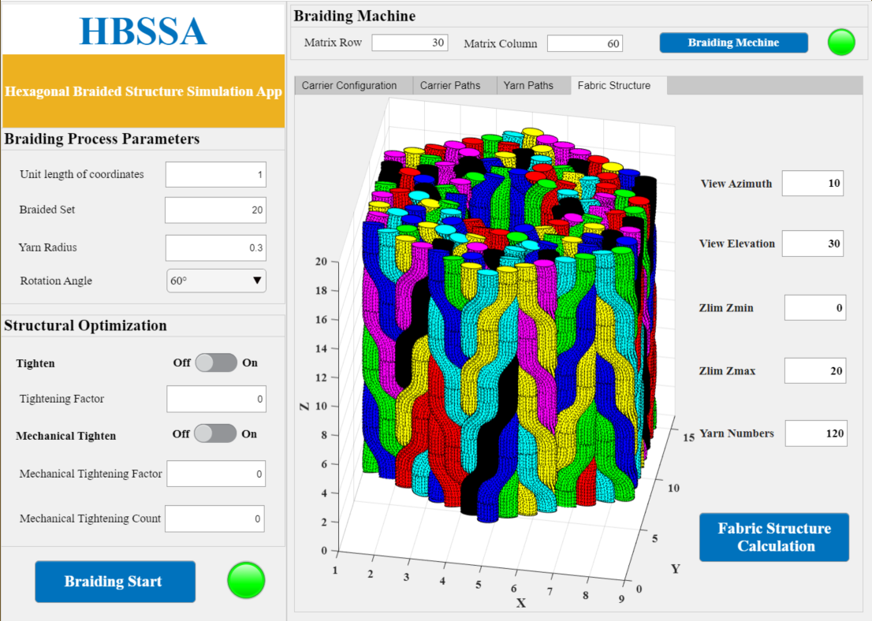

Change the coordinate width to observe the internal structure of the yarn

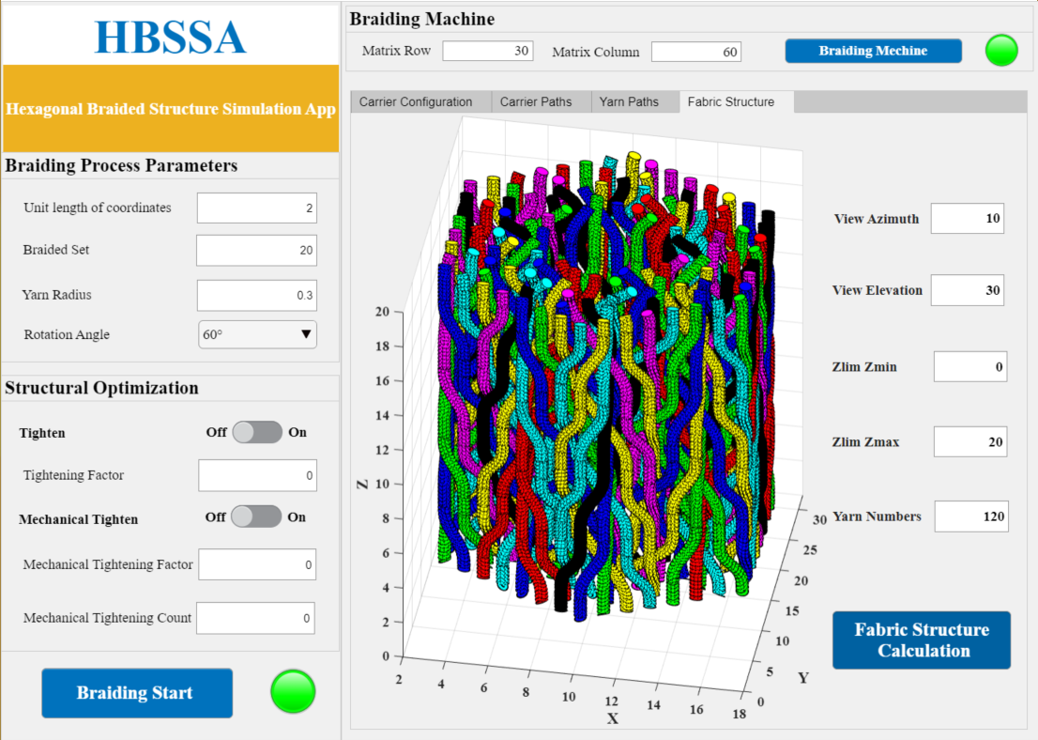

## Cautions

1. After each change to the braid parameters, click on the **Braiding Start** button to let the software do the calculations.
2. To prevent the software from bugs that cause the simulation results to remain unchanged, after closing the tightening switch, the parameter change to 0 should be made before the software reads the option to close the tightening factor.
3. In the simulation result diagram, you can rotate, move, zoom in and out and mark the coordinate position in 3D by placing the mouse on the diagram.